KL Bakery User Manual

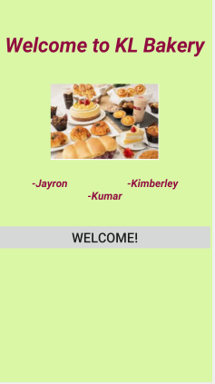

KL Bakery Customer Login Guide

Step 1: Click the CUSTOMER LOGIN button.

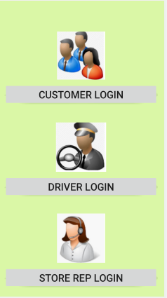

KL Bakery Customer Login Screen

Step 2: Not a Registered Customer? Click JOIN NOW! Note: All Registered Customers move to step 3.
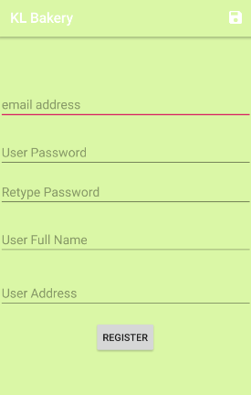

Step 3: Registered Customers enter their username and password and then click SIGN IN!

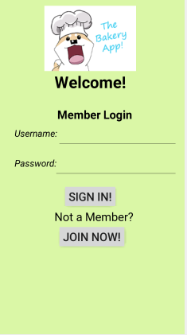

Step 4: Once the customer has logged in, the Customer’s Profile Information and Pending Orders are displayed. If customers want to proceed to check out, they click the CONFIRM ORDER AND LOGOUT button. If a customer wants to continue shopping, they click the GO SHOP button.

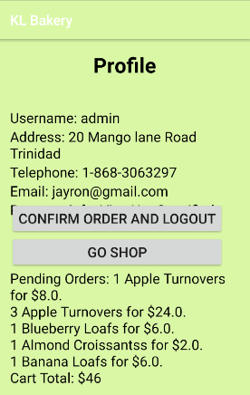

Step 5: Once the GO SHOP button is clicked, a Category Listing of all the products sold by KL Bakery is displayed.

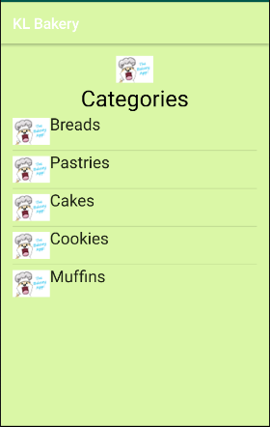

Step 6: Once a customer selects one of the Categories listed, e.g. Bread, a list of all types of bread sold by KL Bakery is displayed.

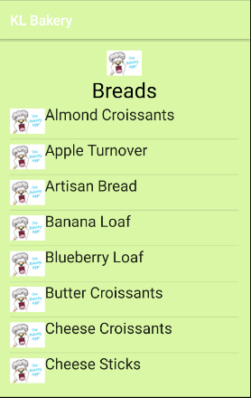

Step 7: Once a customer selects a category, e.g. Bread and the type of bread is selected e.g. Almond Croissants, the customer can specify the Quantity and add the Item to the Basket by clicking the button. Once completed, the customer can return to the CART by clicking the cart button.

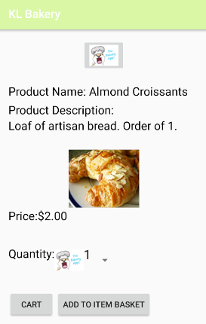

Step 8: If the Customer wants to proceed to check out, they click CONFIRM ORDER AND LOGOUT button or if they want to continue shopping then they click the GO SHOP button.

